1. Change icon ever single page with size -> width : 180px

Follow sample in Home Page commit : <https://github.com/irwansaifranto/pge-bizpage/commit/f5c3f51407fad6869c8ecb07018cd68c6b2d3ca5>



2. Add icon LANG. changer  
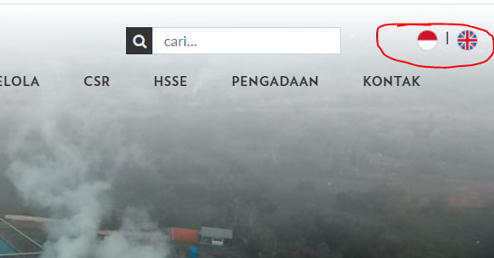

3. Redesign form search and make it similar with form search pge site   
